Suffolk Credit Union welcome you to attend our Annual General Meeting on Thursday 17th June 2021 @ 12.30pm
Please take a couple of minutes to read through this document, so you understand how to join the meeting and take part.
We will be using the GoTo Webinar platform for the meeting, hosted by ABCUL, the Association of British Credit Unions. ABCUL have hosted a number of AGMs and SGM’s for other credit unions across the UK over recent weeks, so everything is tried and tested!
Attending the meeting
Please click on the link below to ‘register’ with ABCUL before the meeting.
https://attendee.gotowebinar.com/register/192436939226296589
Simply enter your First Name, Last Name, Email & Membership Number, as on the screenshot below, then press the blue ‘Register’ button. All done! There is no cost to taking part.

You will receive a confirmation email immediately, from Jackie Littlewood at ABCUL, with a link to join the meeting.
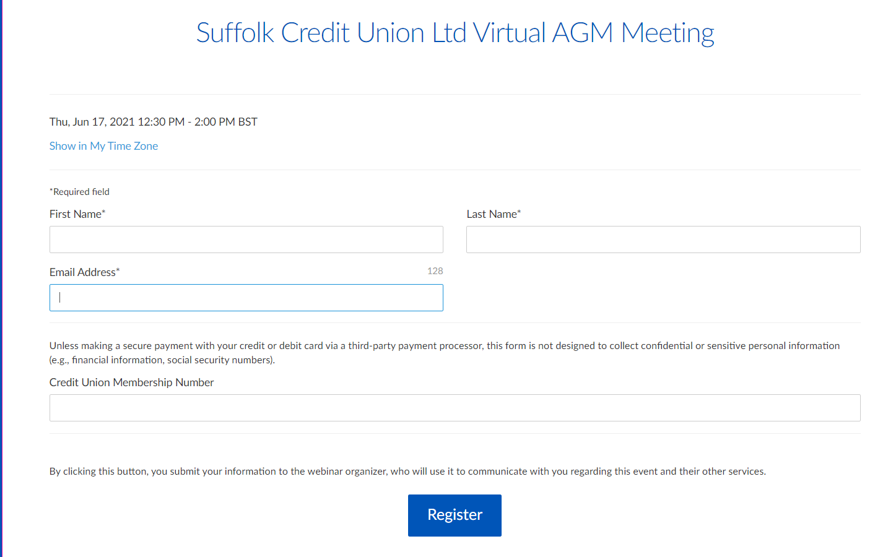
You will receive a confirmation email immediately, from Jackie Littlewood at ABCUL, with a link to join the meeting.
Thank you for registering for "Suffolk Credit Union Ltd Virtual AGM Meeting ".
Please send your questions, comments and feedback to: members@abcul.org
How To Join The Webinar
Thu, Jun 17, 2021 12:30 PM - 2:00 PM BST
Add to Calendar: Outlook® Calendar | Google Calendar™ | iCal®
1. Click the link to join the webinar at the specified time and date:
Join Webinar

Note: This link should not be shared with others; it is unique to you.
Before joining, be sure to check system requirements to avoid any connection issues.
2. Choose one of the following audio options:
TO USE YOUR COMPUTER'S AUDIO:
When the webinar begins, you will be connected to audio using your computer's microphone and speakers (VoIP). A headset is recommended.
--OR--
TO USE YOUR TELEPHONE:
If you prefer to use your phone, you must select "Use Telephone" after joining the webinar and call in using the numbers below.
United Kingdom: +44 20 3713 5012
Access Code: 429-224-776
Audio PIN: Shown after joining the webinar
Webinar ID: 957-559-219
To Cancel this Registration
If you can't attend this webinar, you may cancel your registration at any time.

Ahead of the meeting
As this is a virtual meeting, we are unable to ‘hand out’ the usual information packs. We have already shared specific documents such as the Agenda & Minutes via email or by post where needed. They will also be added to our website at the link below. Please follow the link to view these ahead of the AGM
https://suffolkcreditunion.onesuffolk.net/latest-newsletter/
At the virtual meeting
At the start of the AGM, we will run through how the virtual AGM will work.
During the meeting, you can 'ask virtual questions' at any time by typing in the 'Question' section. We will be monitoring questions throughout the meeting, and will either reply in the question area, raise your question during Any Other Business, or in some cases, respond afterwards.
All Attendees will be ‘muted’ during the presentation. Ahead of a vote, the Presenter will ask members to use the ‘Hand Raising’ function to be unmuted for verbal questions.
Voting will be live in the meeting with instant results. The vote will be on screen, and members simply select their preference. We will hold a test vote at the start of the meeting, so that everybody can practice before the main voting takes place.
Thank you for taking time to read these instructions. We look forward to welcoming you to our virtual AGM.
If you have any queries in the meantime, please do not hesitate to get in touch.

